PERSONALIZED INVITATION USING CANVA

# 1.INTRODUCTION.

A small card bearing information (such as name and address)about a invitation representative.

# OVERVIEW OF THE PROJECT.

In this project , first we creat the empathy map about the topic professional invitation card. Next design the brainstorming map by collecting the ideas from group members . By brainstorming ideas , we design the professional.

Personalized invitation using canva.

# PURPOSE OF THE INVITATION CARD.

A thoughtfully-designed invitation card does more than carry your contact information , and set your small invitation apart from others.

# 2)PROBLEMS DEFINITION AND DESIGN THINKING .

2.1 EMPATHY MAP.

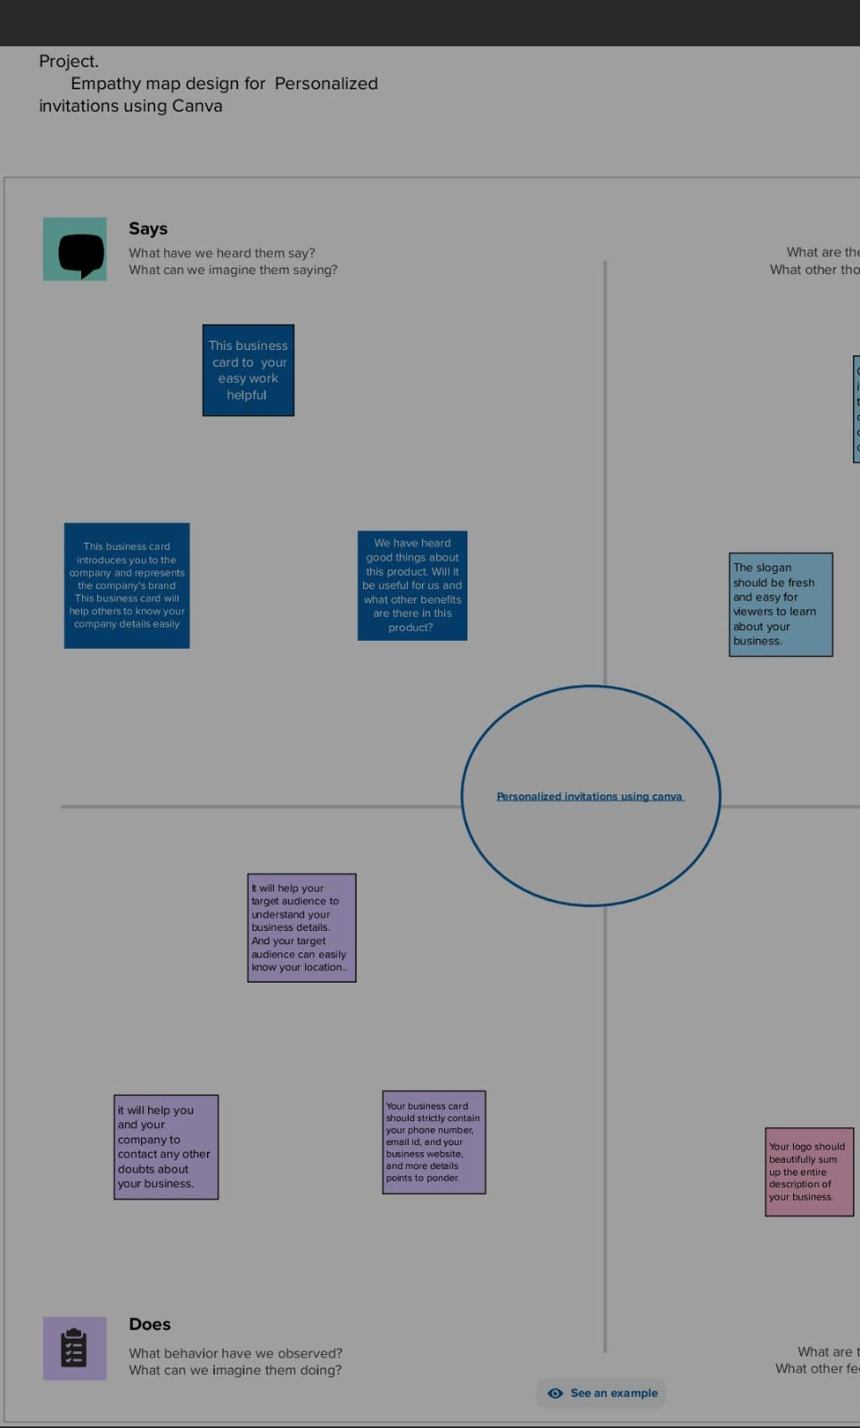

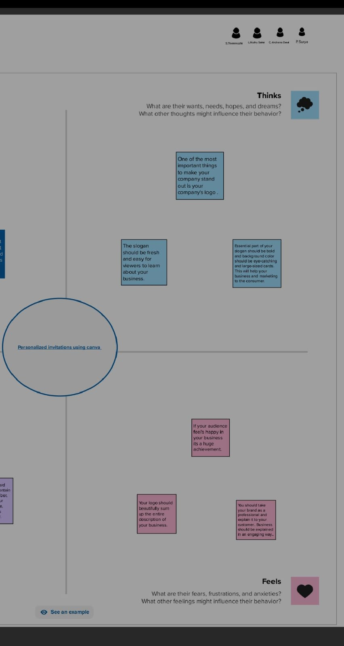

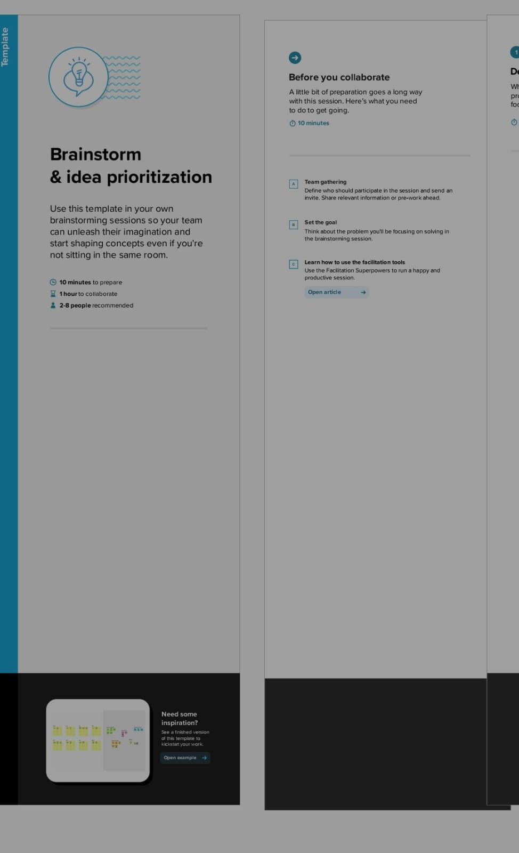

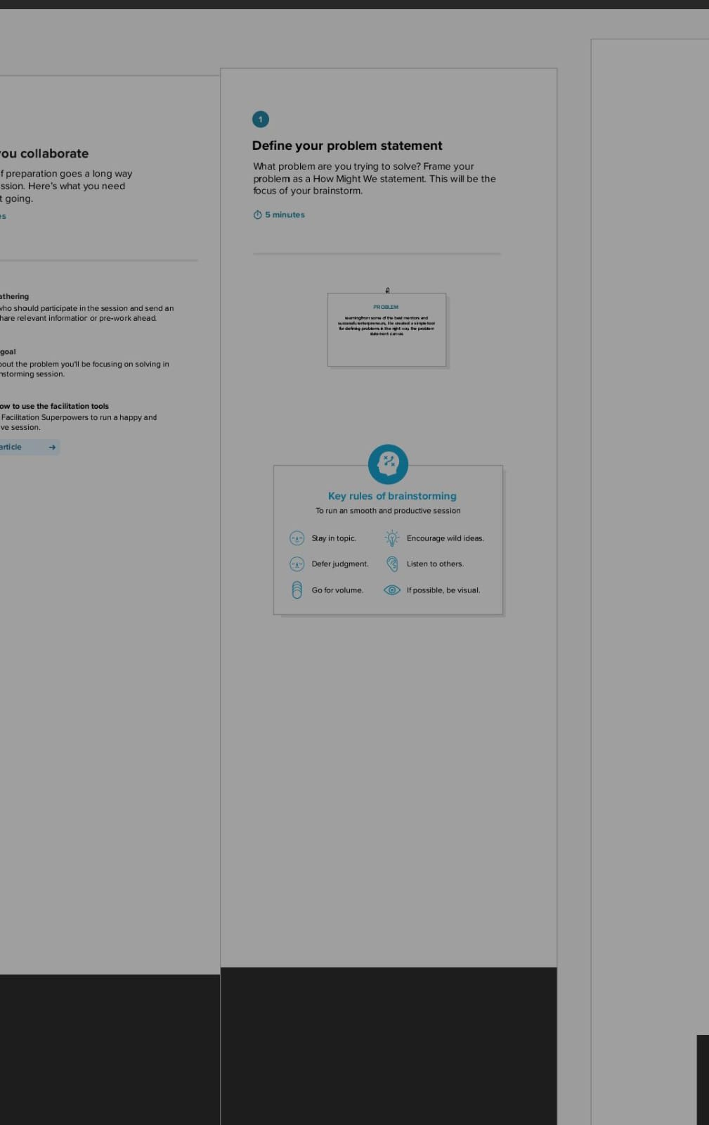

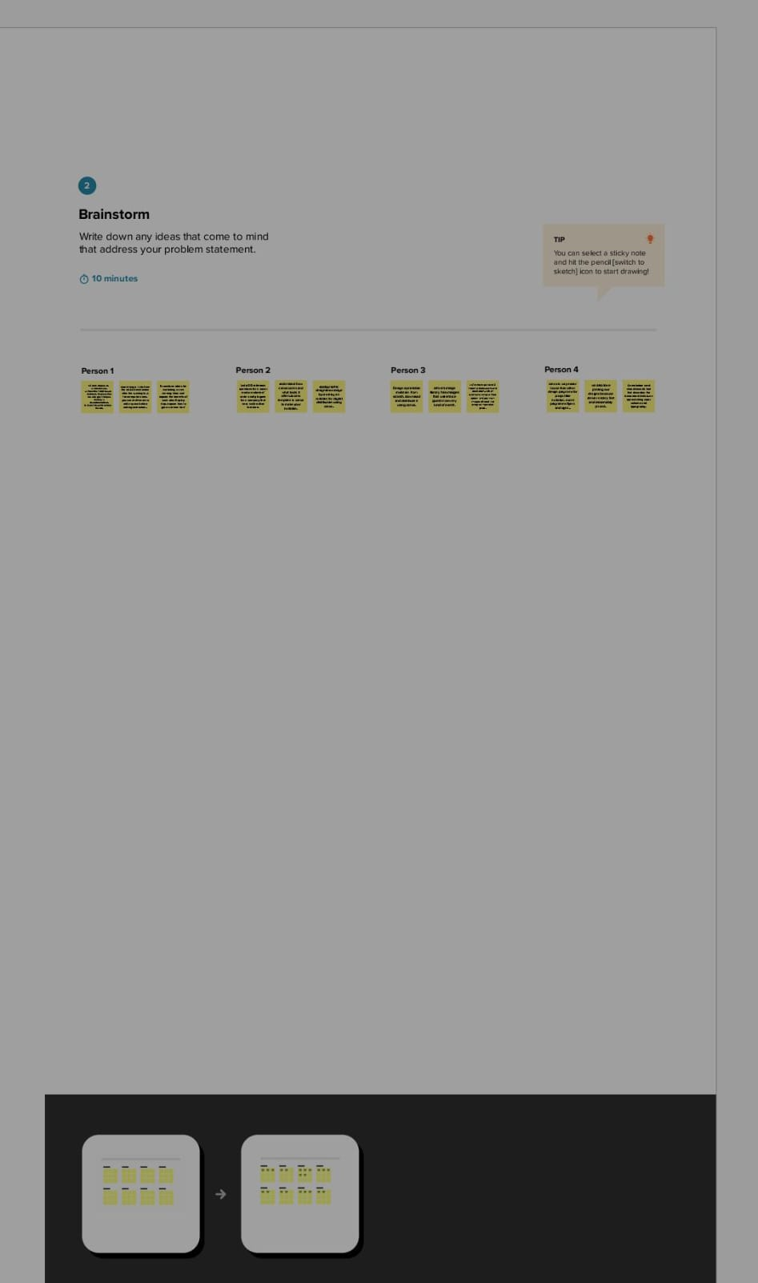

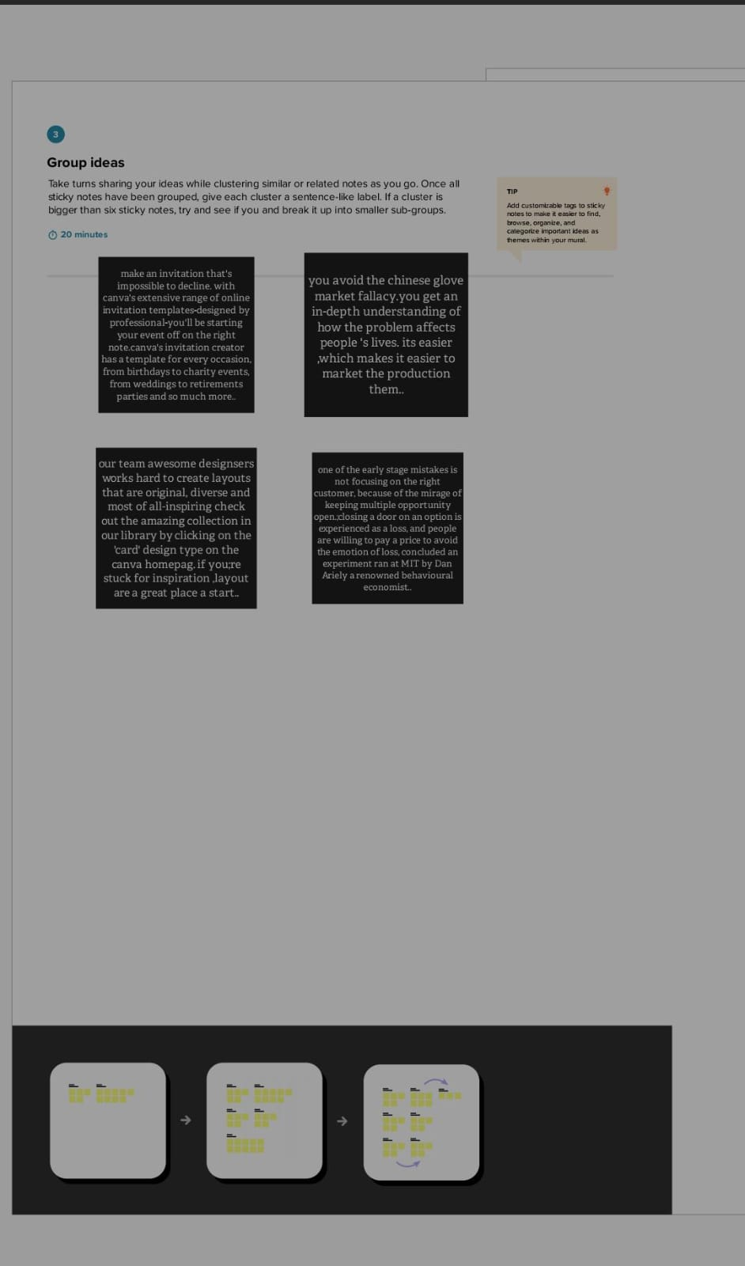

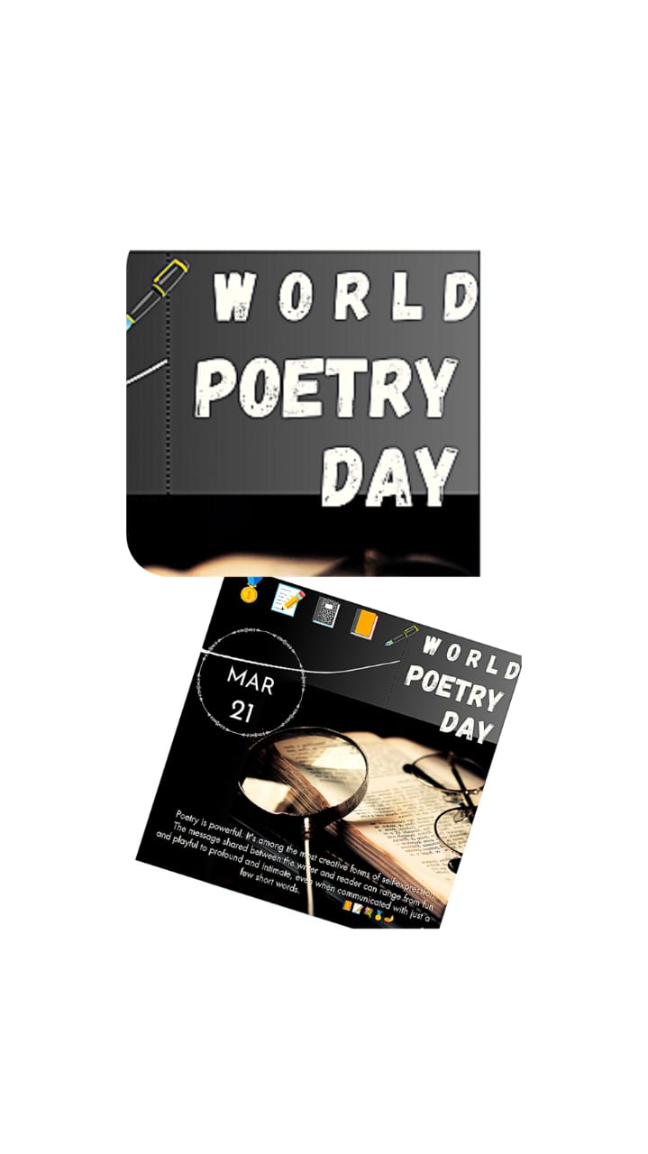

RESULT.



# ADVANTAGES.

1)Also you can always tell when the invite has been delivered to the recipient or not . it is customizable.

Whether the groom likes his invite to be funny and quickly or the bride wants an elegant and romantic touch to the invite – it call all be done.

2)create epic party invitation with canva. With hundreds of free layouts to choose from and a liberay packed with awesome images. Creating the perfect party invitation in canva is ridiculously easy.

# DISADVANTAGES.

1. Limited export settings.
2. Limited compatibility with other design tools .
3. Limited mobile app fuctionally ..
4. Limited access to premium features.
5. Limited customization optio.
6. Lacks to provide advanced features
7. Limited font and logo options.
8. Limited control over image saturation.

# APPLICATION.

This vector graphics left you work with a blank canvas to create any kind of invitation using numerous shapes, effects,and other interative elements.

# CONCLUSION.

Even a Non-designer can become a designer using canva .canva is very simple to use and user-friendly..

# FUTURE SCOPE.

Canvas future scope will largely depend on the direction that the company takes. There are a few potential ways that users could earn money by using the canva..